Search

Create new Account

Home Screen

(my group page)

Login

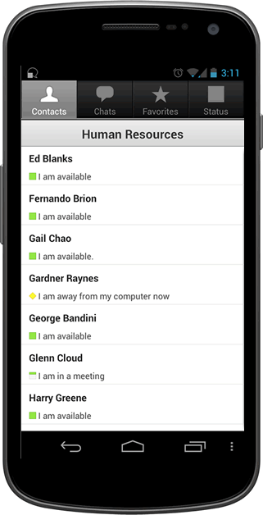

Create New Account

forgot password

**Carpooling for the Green Initiative**

User Name

Password

forgot user name



**Carpooling for the Green Initiative**

User Name

Password

Confirm Password

First Name

Last Name

**Create New Account**

Street Address

City

State

Zip

Do you own a car?

Yes

No

Phone Number

Email

Login Screen

Create New Account part 1/2



Location: 145 Marcus way

Available: F

Depart to work: 7:15 am

Depart to home: 5:30 pm

Fee: $0.80 (daily)

John Doe

**Carpooling for the Green Initiative**

Group I am In

Location: 152 Marcus way

Available: M W

Depart to work: 7:15 am

Depart to home: 5:30 pm

Fee: $0.80 (daily)

Will Harmon

Location: 186 Marcus way

Available: T TH

Depart to work: 7:15 am

Depart to home: 5:30 pm

Fee: $0.80 (daily)

Jane Smith

Group I Drive



Location: 145 Marcus way

Available: F

Depart to work: 7:15 am

Depart to home: 5:30 pm

Fee: $0.80 (daily)

John Doe (you)

**Carpooling for the Green Initiative**

Group Information

John Doe (you)

Location: 186 Marcus way

Phone: 276-999-9999

Email: JoneDoe@email.com

John Doe

Members

Location: 145 Marcus way

Phone: 276-999-9999

Email: JoneDoe@email.com

Sam Davis



Location: 145 Marcus way

Available: F

Depart to work: 7:15 am

Depart to home: 5:30 pm

Fee: $0.80 (daily)

John Doe

**Carpooling for the Green Initiative**

Group I am In

Location: 152 Marcus way

Available: M W

Depart to work: 7:15 am

Depart to home: 5:30 pm

Fee: $0.80 (daily)

Will Harmon

Location: 186 Marcus way

Available: T TH

Depart to work: 7:15 am

Depart to home: 5:30 pm

Fee: $0.80 (daily)

Jane Smith

Group I Drive

View Group Members

Leave Group



Location: 145 Marcus way

Available: F

Depart to work: 7:15 am

Depart to home: 5:30 pm

Fee: $0.80 (daily)

John Doe

**Carpooling for the Green Initiative**

Group I am In

Location: 152 Marcus way

Available: M W

Depart to work: 7:15 am

Depart to home: 5:30 pm

Fee: $0.80 (daily)

Will Harmon

Location: 186 Marcus way

Available: T TH

Depart to work: 7:15 am

Depart to home: 5:30 pm

Fee: $0.80 (daily)

Jane Smith

Group I Drive

Send Departure Message to Group

Edit Pickup Information

View Group Members

Delete Group



Location: 145 Marcus way

Available: F

Depart to work: 7:15 am

Depart to home: 5:30 pm

Fee: $0.80 (daily)

John Doe (you)

**Carpooling for the Green Initiative**

Group Information

John Doe (you)

Location: 186 Marcus way

Phone: 276-999-9999

Email: JoneDoe@email.com

John Doe

Members

Location: 145 Marcus way

Phone: 276-999-9999

Email: JoneDoe@email.com

Sam Davis

Edit Car Description

View Car Description

Edit Pickup Information



Location: 145 Marcus way

Available: F

Depart to work: 7:15 am

Depart to home: 5:30 pm

Fee: $0.80 (daily)

John Doe (you)

**Carpooling for the Green Initiative**

Group Information

John Doe (you)

Location: 186 Marcus way

Phone: 276-999-9999

Email: JoneDoe@email.com

John Doe

Members

Location: 145 Marcus way

Phone: 276-999-9999

Email: JoneDoe@email.com

Sam Davis

Get Directions

Call

Message

Remove Member



Location: 145 Marcus way

Available: F

Depart to work: 7:15 am

Depart to home: 5:30 pm

Fee: $0.80 (daily)

John Doe

**Carpooling for the Green Initiative**

Group I am In

Location: 152 Marcus way

Available: M W

Depart to work: 7:15 am

Depart to home: 5:30 pm

Fee: $0.80 (daily)

Will Harmon

Location: 186 Marcus way

Available: T TH

Depart to work: 7:15 am

Depart to home: 5:30 pm

Fee: $0.80 (daily)

Jane Smith

Group I Drive

Messages

JANE SMITH IS NOW DEPARTING.

Stanely Johnson wants to join your group.

Jonny William Wants to join your group.

Accept

Decline

Accept

Decline

3



Location: 145 Marcus way

Available: M W F

Depart to work: 7:15 am

Depart to home: 5:30 pm

Fee: $0.80 (daily)

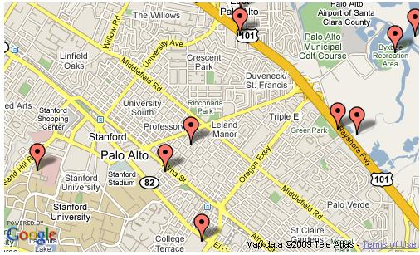

John Doe



**Carpooling for the Green Initiative**

Location: 145 Marcus way

Available: T TH

Depart to work: 7:15 am

Depart to home: 5:30 pm

Fee: $0.80 (daily)

Steve Smith



**Carpooling for the Green Initiative**

Max Passengers

Vehicle Type

**Create New Account**

Create Account

Cancel

Do you own a vehicle?

Yes

No

Truck

Van

SUV

Car

Car Description

Other

Example, my car is a two door, white Toyota Camry with a sun roof.

Search results

Create new Account part 2/2

Selection menu if your own group is selected

Selection menu if contact me is selected



Location: 145 Marcus way

Available: M W F

Depart to work: 7:15 am

Depart to home: 5:30 pm

Fee: $0.80 (daily)



John Doe (you)



**Carpooling for the Green Initiative**

Location: 145 Marcus way

Available: T TH

Depart to work: 7:15 am

Depart to home: 5:30 pm

Fee: $0.80 (daily)

Steve Smith

Edit

Delete

Send message to group

View group members



Location: 145 Marcus way

Available: M W F

Depart to work: 7:15 am

Depart to home: 5:30 pm

Fee: $0.80 (daily)



John Doe (you)



**Carpooling for the Green Initiative**

Location: 145 Marcus way

Available: T TH

Depart to work: 7:15 am

Depart to home: 5:30 pm

Fee: $0.80 (daily)

Steve Smith

Call Driver

Message Driver

Send Invite Request

View group members



Mile Radius (25 mile Limit)

Pick up Address

Search

Cancel

**Carpooling for the Green Initiative**

**Carpooling for the Green Initiative**



Days for Pickup

9:00 AM

Pickup Address

M T W Th F Sat Sun

Departure

to Home

5:00 PM

Pickup time:

Create Pickup Location

Cancel

3

Available Seats:

3

Drivers Fee: $

Calculate Fee

Menu if search is selected

Menu if create meeting place is selected



Location: 236 Marcus way

Abingdon Va 24210

276-777-7777

John.Doe@yahoo.com

Available: M W F

Contact Me

Steve Smith

145 Marcus way

Abingdon Va 24210

276-999-9999

John.Doe@yahoo.com

Available: M W F

Fee: $0.80 (daily)

Contact Me

John Doe (Driver)

Location: 156 Marcus way

Abingdon Va 24210

276-888-8888

Jane.Doe@yahoo.com

Available: M W F

Contact Me

Jane Doe

Menu if personal settings is selected

Menu if view group members are selected

**Carpooling for the Green Initiative**



**Carpool**

John

User Name

Password

Doe

John.Doe

******

******

Confirm Password

First Name

Last Name

**Account Management**

Street Address

145 Marcus Way

City

Abingdon

State

Zip

VA

24210

Do you own a car?

Yes

No

Phone Number

276-999-9999

Email

John.Doe@yahoo.com



Add Total to Fee

Exit Calc

Calculate Fee

Vehicle’s mpg

Distance of trip (miles)

Number of Passenger

(do not include driver)

Cost for gas (per gal) $

Total

$0.00

Driver’s Fee Calculator

Driver’s Fee Calculator

**Carpooling for the Green Initiative**

Calculation for Driver’s Fee:

Total= 

Google maps image: <http://www.codeproject.com/Articles/36151/Show-Your-Data-on-Google-Map-using-C-and-JavaScrip>

Green icon: <http://www.graphicsfuel.com/wp-content/uploads/2011/03/gps-map-icons.png>

Android phone <http://www-10.lotus.com/ldd/insidelotusblog.nsf/dx/new-sametime-chat-apps-for-android>

Log in

Username

Password

Account creating

First Name

Last Name

User Name

Password

Address

Street, city, state, zip

Phone number

Car?

make

model

year

number of occupants (vehicleSize)

Driver?

Days will drive?

* pickup address
  + depart time
* meet time
* work leave time
* work arrival time

Group list

* Days will drive?
* pickup address
* depart time
* meet tme
* work leave time
* work arrival time